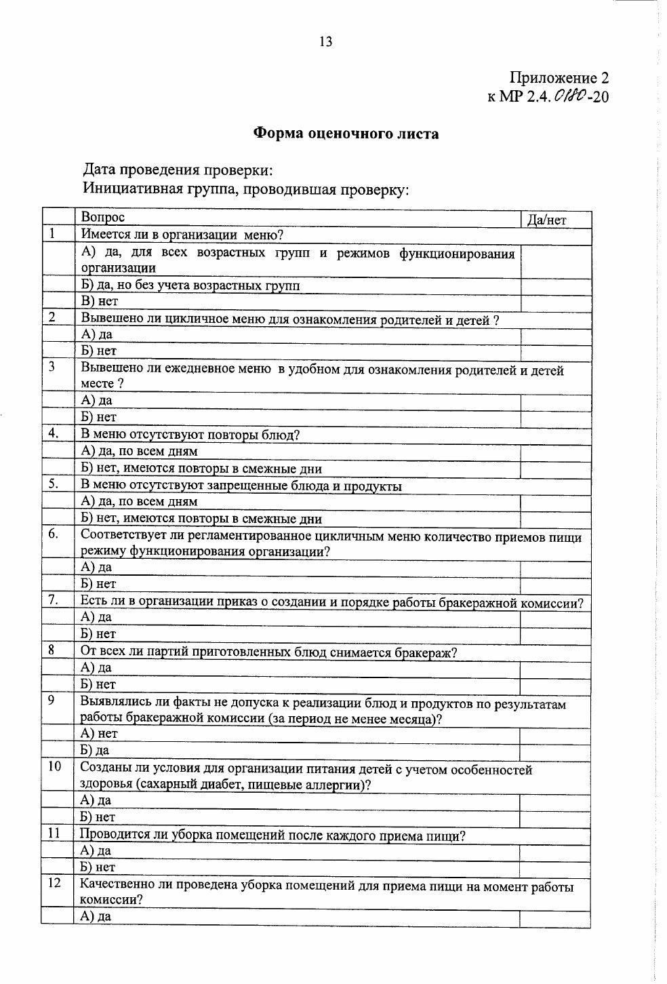

Дата контроля: ______________________________

Время контроля: ____________________________

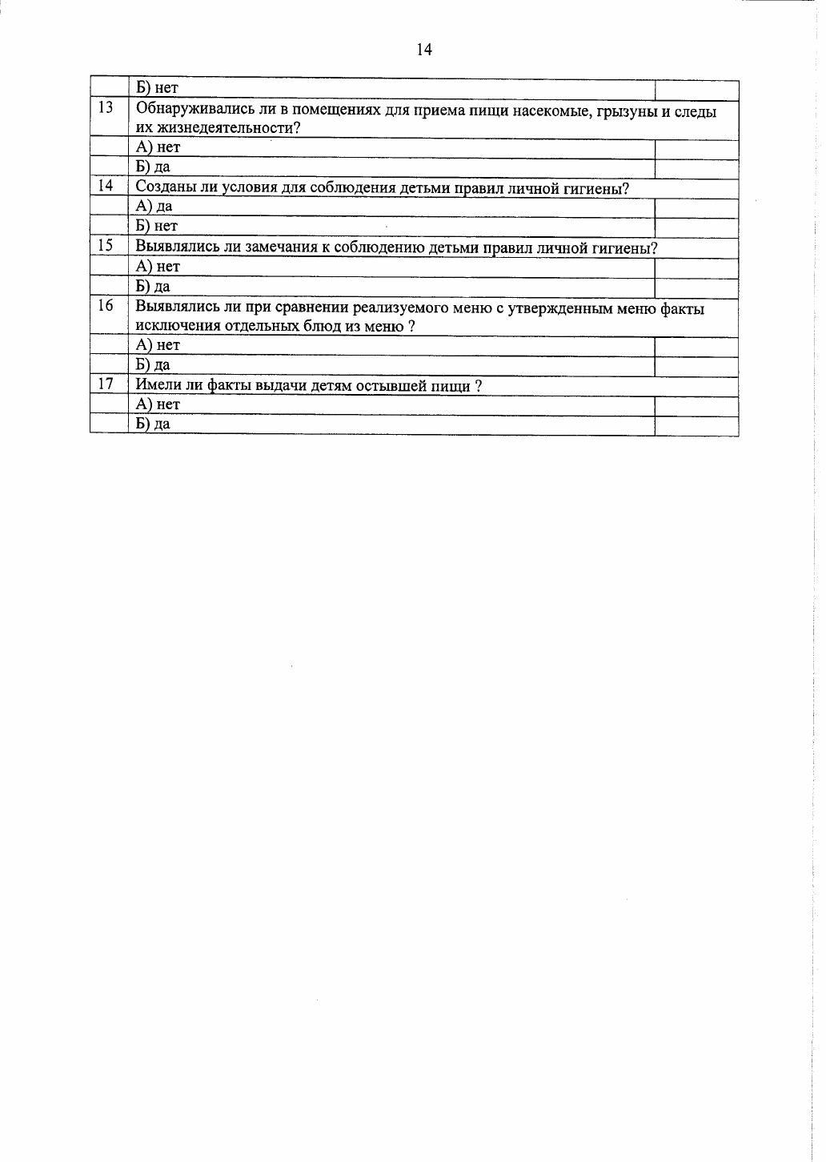

Подписи членов комиссии

_______________________________________________________________________________________________________________________________________________________________________________________________________________________________________________________________________________________________________________________________________________________________________________________